Государственное бюджетное образовательное учреждение
среднего профессионального образования
«Курганинский аграрно-технологический техникум»
Краснодарского края

Разработка урока по теме:
«США. Путешествие по США. Государственное устройство США»
 | 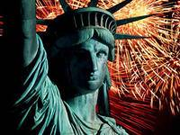 | 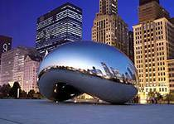

Разработала: преподаватель иностранного языка
Говердовская О.Н.

г. Курганинск, х. Красное Поле, 2013 г.
Тема урока: «США. Путешествие по США. Государственное устройство США»
Цель: применение ЗУН на практике.
Задачи:
- Обобщение и систематизация фактического материала по страноведению.
- Дальнейшая автоматизация изученного языкового материала.
- Развитие произносительных навыков.
- Формирование уважения к Соединенным Штатам Америки.
- Развитие познавательных интересов учащихся.
- Формирование лингвистического отношения к слову.
- Расширение кругозора учащихся.
Форма проведения урока - ролевая игра.
Формы организации познавательной деятельности: фронтальная, групповая, индивидуальная.
Мотивация целей: удовлетворение потребностей в общении.
Методы обучения: репродуктивный, частично- поисковый, объяснительно- иллюстративный.
Роли учащихся на уроке: гид, две соревнующиеся между собой команды экспертов по различным вопросам страноведения США (по 5 - 6 человек в каждой) и группа болельщиков-туристов.
Педагогические технологии: личностно- деятельностно-коммуникативная, игровая.
Оборудование: карта США; фотографии достопримечательностей; предметы (модели или изображения), изобретенные в США.

Ход урока:
Teacher: Good afternoon, everyone. Today we are travelling through the United States of America. We have two teams of experts who will help us during our journey and at the end we'll see which team is the best. The people in this team are not experts so we will call them tourists. Here we have our judges. They are pupils of the eleventh form, so they are worthy of respect. And here is our guide.
Guide: Ladies and gentlemen! Welcome to the United States of America. I'm pleased to meet you. The weather is wonderful, and I hope that our journey will be too. Let me introduce myself. My name is… I am your guide and group leader. I shall accompany you everywhere. I'll show you everything. You'll travel through the country. You'll visit cities and historical places, museums and theatres. There are a lot of interesting things to see. You'll get to know the country and its capital. You'll meet people and make friends. I hope that we'll become friends.
Teacher: Before our journey let's listen to our experts. They are authorities in their fields of Geography and Economics.
Представители команд делают сообщения, используя карту США.
(приложение №1)
Team 1: The USA is situated in the central part of the North American continent. Its western coast is washed by the Pacific Ocean and its eastern coast by the Atlantic Ocean. The area of the USA is over nine million square kilometres. The continental part of the USA consists of two highland regions and two lowland regions. The highland regions are the Appalachian Mountains in the east, and the Cordillera and the Rocky Mountains in the west. The highest peak in the Appalachian Mountains is 2,037 metres high. The highest peak of the Cordillera in the USA is 4,418 metres. Between the Rocky Mountains and the Appalachian Mountains are the central lowlands, which are called the prairie and the eastern lowlands, called the Mississippi valley. The five Great Lakes, between the USA and Canada, are joined together by short rivers or canals, and the Saint Lawrence River joins then to the Atlantic Ocean. In the west of the USA there is another lake called the Great Salt Lake. The main rivers of the USA are Mississippi, which flows into the Gulf of Mexico, the Colorado and the Columbia which flow into the Pacific Ocean, the Saint Lawrence River and the Hudson River, which flow into the Atlantic Ocean. The USA is very large country, so it has several different climatic regions. The coldest regions are in the north and north-east where much snow falls in winder. The south has a subtropical climate. Hot winds blowing from the Gulf of Mexico often bring typhoons. The climate along the Pacific coast is much warmer than that of the Atlantic coast. The region around the Great Lakes is known for its changeable weather.
Team 2: The USA is a highly developed industrial country, and its agriculture is highly mechanized. Coal is found in many parts of the country: in the Cordillera Mountains, in the state of Kansas, in the east near Birmingham and Pittsburgh. The state of Illinois is especially rich in coal. Iron is mined near the Great Lakes and in other areas. The USA has rich oil-fields in California, Texas, Alaska and other regions. It holds first place in the capitalist world for production of coal, iron, oil and natural gas. The heavy industries are for the most past in the Middle West, in the region of the Great Lakes, around Detroit and Chicago, in the north-eastern states and near Birmingham. The automobile industry and all kinds of machine-building are highly developed especially in and near Detroit, in California and in the areas of heavy industry. Ship-building is developed along the Atlantic coast and also in San Francisco and Seattle on the Pacific coal. The textile industry is concentrated in the north- east, in Boston and other cities; but it is especially well developed in the South, where much cotton is grown, in the Mississippi valley. The USA has a highly developed railway system. It also has the best system of roads in the capitalist world. The Great Lakes and the rivers, especially the Saint Lawrence River and the Mississippi, are used for transport. American agriculture produces more food products than any other capitalist country. Much of then are exported. In the Middle West very much grain is grown. Fresh fruit and vegetables come all the year round from the southern regions, especially Florida, from California and south-western states. The highlands in the west of the country are famous for their cattle-farming. Poultry-farming and vegetable growing are concentrated in the countryside near all the big cities.
Teacher: Now our experts are ready for the journey. And what about our tourists? Let's give them this crossword puzzle. Try to guess the words during the journey. If everybody is ready, let's start.
Guide: We are beginning our journey in the most ancient English town in the USA. It is situated on the Atlantic coast. It was founded in 1620. Do you know its name?
(It is New Plymouth.) (приложение №2)
Now we are on the American continent.
Teacher: The American continent differs very much from Europe. There are a lot of animals in America, which you can't find in Europe. I am sure that you know about them. Let our experts give you some riddles about these animals.
Представители команд по очереди задают вопросы болельщикам-туристам.
(приложение №3)
- A big bird living in North America (bald eagle),
- A large animal of the cat family having a golden fur with black spots (jaguar),
- An American snake (rattle-snake),
- The bison of North America (buffalo),
- A small brightly coloured bird (humming-bird),
- A bear with large head and body and brown or grey fur (grizzly-bear),
- A toothless animal eats ants (anteater),
- A small animal having brownish grey fur and black mask like markings (raccoon),
- An animal of the dog family (coyote),
- An animal having an armour like shell of plates (armadillo).
Teacher: But it is not only animals that are different. When the first Europeans came to America they saw many strange plants and they took some of them to Europe. Tourists, do you know which ones they were?
(Potato, tomato, tobacco, cocoa, maize, etc.)
Guide: Now along the Atlantic coast we are going to the city, which has played a very important part in the American history. I am sure you know this city very well.
(It is Boston.) (приложение №4)
Teacher: The USA is not an old country but it has a very interesting history. There are some dates on the blackboard. What do they mean to the Americans? Let's ask our experts.
Team 2:
- In 1492 Christopher Columbus discovered the American continent.
- In 1620 the first Englishmen came to America on the “Mayflower”.
- If I am not mistaken, in 1773 an incident named the Boston Tea Party took place.
- From 1775 to 1783 the war for independence of American colonies from British rule lasted.
- In 1776 the Declaration of Independence was written by Thomas Jefferson and some other people and adopted in Philadelphia.
- As far as I remember, the US Constitution was adopted in 1788.
Team 1:
- In 1801 Washington, the capital of the United States was built in District of Columbia.
- As far as I know, in 1848 the gold rush in California took place.
- President Lincoln freed the Negro staves in 1863.
- From 1861 to 1865 the Civil War between the states lasted in America.
- In 1867 the United States bought Alaska from Russia, if I am not mistaken, for a little more than seven million dollars.
- In 1969 Neil Armstrong became the first person to walk on the Moon.
Guide: You know that the United States of America is a very large country. So let's take a plane to get to the Pacific coast.
Teacher: Let our guide tell us the nicknames of the states we are flying over now. I think we can guess their real names. Will you show us the route on the map?
Guide (показывает на карте место после того, как туристы правильно назовут штат.):
- the Keystone State (Pennsylvania),
- the Lake State (Michigan),
- the Land of Lincoln (Illinois),
- the Central State (Kansas),
- the Blackwater State (Nebraska),
- the Equality State (Wyoming),
- the Salt Lake State (Utah),
- the Golden State (California).
Guide: There are two great places of interest here, near Los Angeles. What are they?
(They are Hollywood and Disneyland.) (приложение №5)
Teacher: California is the land of everlasting holiday. But there are of course a number of national holidays in the country. What can our experts tell us about them?
Даты праздников написаны на доске.
Team 1:
On the first of January, New Year’s Day, all banks, stores, factories and schools are closed. People do not go to bed until after midnight on December 31. They like to see “the old year out and the new year in”. Many people give parties on New Year’s Eve.
The fourteenth of February is St. Valentine’s Day. It is a day of love and friendship. It is widely celebrated among persons of all ages by the exchange of special greeting-cards, valentines. Flowers and candy are favourite presents which friends and family give each other.
On the second Sunday of May, Mother’s Day, Americans honour their mothers. They send their mothers a card or a gift, present flowers, prepare dinner for them.
The last Monday in May is Memorial Day, or Decoration Day. It is dedicated to those who fell in the War of Independence, in World War I or as anti-fascist fighters in World War II. On this day, patriotic songs are also sung on the radio and TV.
The Fourth of July is Independence Day. It is the biggest national holiday of the USA. The Declaration of Independence was proclaimed in Philadelphia on July 4, 1776, when the American colonies were fighting for independence against England.
Team 2:
On October 12, 1492, Columbus discovered the first island in America. The first celebration of the discovery, Columbus Day, was held in New York City in 1792.
Halloween is celebrated on October 31. It is a holiday for young people and children. They make lanterns out of pumpkins. Some people make parties and dress up like ghosts and witches.
Another holiday is Veterans’ Day on November 11. During the Day there are usually parades and ceremonies held in honour of those who fell in the two World Wars.
Thanksgiving Day comes on the fourth Thursday in November. In the autumn of 1621, the Pilgrim Fathers celebrated their first harvest festival in America and called it Thanksgiving Day. Since that time Thanksgiving Day has been celebrated every year.
Christmas is celebrated on December 25. It is a religious holiday. Just before Christmas day people send Christmas and New Year greetings to their friends and relatives. Stores, post-offices, banks and business places close for this day, schools and colleges close between Christmas and New Year’s Day. People usually stay at home at Christmas-time, and spend the day with their families.
Teacher: But the Americans don't just have holidays. They also work, and they work a lot. New inventions are appearing every day. Many of them are made in the USA. Here are some things which were invented in America. What can you tell us about them?
Выносят поднос с предметами, изобретенными в США. Представители команд по очереди берут предметы, показывают и говорят о них.
- The telephone was invented in 1876 by Alexander Bell.
- The electric light bulb was invented in 1879 by Thomas Edison.
- The steamboat was invented in 1807 by Robert Fulton.
- The nylon was invented in 1927.
- The transistor was invented in 1947.
- The structure of the DNA was invented by Watson in 1962.
Guide: Now we are going to visit the largest city of the USA. It is the industrial and cultural centre of the country. What city is it?
(It is New York.)(приложение №6)
For many people New York is the symbol of the USA. First it was inhabited by the Dutch, then by the English but people from all over the world live here now.
Teacher: Yes, that's true. Descendants of people from all over the world live iv the USA. Now they have a common history, culture and language. What language do the Americans speak?
Yes, English. But it is not the same language as the English people speak. There is a difference in the spelling of some words. Here are the words written the American way. Please, can two tourists come up to the blackboard and give the British spellings of the words.
American | British
catalog | catalogue
program | programme
color | colour
labor | labour
honor | honour
traveler | traveller
center | centre
meter | metre
theater | theatre
Some things have different names in America to Great Britain. Please, take the cards with the British words and give their American equivalents.
There is also a difference in pronunciation. I'll read you some of the words the American way and you will say them as the English do.
Words | American | British
brass | [brжs] | [br?:s]
glass | [glжs] | [gl?:s]
dance | [dжns] | [d?:ns]
can’t | [kжnt] | [k?:nt]
ask | [жsk] | [?:sk]

Teacher: And now I would like to present a presentation about “Political system of the USA” (приложение №9 – презентация)
Guide: Next we'll visit the capital of the USA, Washington. It is not a large city. There is no industry in it, just administrative buildings and places of interest. What are they?
(The Capitol Building,
the White House,
the Lincoln Memorial,
(приложение №7)
Teacher: Now let's talk about some other places of interest in America. Maybe our experts can tell us about them.
Представители команд описывают фотографии достопримечательностей США.
Team 1:
- The Statue of Liberty on the Manhattan Island meets people coming to America.
- A bridge over the Niagara River connects the two states - Canada to the Left and the USA to the right.
- Here you can see Disneyland built by Walt Disney Los Angeles.
- This is San Francisco, the capital of the state of California.
- The Rocky Mountains are in the west of the USA. In the Rockies there are several peaks about five thousand meters high.
- This is Columbia University in New York.
- In this picture you can see the Pentagon.
- And this is the Capitol, the seat of the Congress.
Team 2:
- The Washington Monument is also called the Pencil. It is 5 hundred and fifty five feet high.
- This is the Golden Gate Bridge in San Francisco. It is situated on the Pacific coast.
- This is the Grand Canyon.
- Manhattan is an island, which forms the heart of New York.
- Boston is known for its universities. Here is one of them.
- Here you can see the United Nations building in New York.
- The White House is the President’s residence.
- The National Gallery of Art is also situated in Washington.
Teacher: And what about the crossword? Have you worked out all the answers? Our judges will check it.
Заполненный кроссворд передается жюри.
I think that our journey is coming to an end. Let the experts ask their final questions to the opposing team. Two questions each, please.
Team 1:
- What is the former name of New York? (New Amsterdam)
- What is the real name of O. Henry? (William Porter)
- Who was the first president of the USA? (George Washington)
- How many states signed the Declaration of Independence? (13)
- Who wrote the first detective stories? (Edgar Poe)
- What river joins the Great Lakes to the Atlantic Ocean? (the St. Lawrence River)
- Which is the largest state? (Alaska)
- What is the region where wheat and maize are grown? (Corn Belt)
- What river flows through Washington, D.C.? (Potomac)
- What is the flag of the USA called? (Stars and Stripes)
Team 2:
- What is the highest building in Washington? (the Capitol)
- What is the name of the parliament? (Congress)
- How many senators are there in the Congress?
- What are the most popular team sports in the USA? (baseball, basketball, football)
- What is the first state of the USA?
- What is the oldest college of the USA? (Harvard)
- What is the longest river? (the Mississippi)
- In what country was the Statue of Liberty made? (France)
- What is the real name of Mark Twain? (Samuel Clemens)
- What is the former capital of the USA? (Philadelphia)
Guide: At the end of our journey we are going to visit one more city. It is situated in the Mississippi valley. It is a cultural centre and the birthplace of jazz. Which city is it?
(It New Orleans is New Orleans.) (приложение №8)
Teacher: Now we are in a cultural centre and our tourists are going to show us an amateur performance. It is an act from one of the most famous American musicals "My Fair Lady" by Alan Lerner. The action takes place at Ascot, in Mrs Higgins's box. Professor Higgins is going to introduce Eliza Doolittle to his mother and her guests.
Let our judges tell us the final score.
The lesson is over.

СПИСОК ЛИТЕРАТУРЫ:
- Английский язык: Учебное пособие для 10 кл. сред. шк./ А.П. Старков, Б.С. Островский. - М.: ООО “Издательство Астрель”: ООО “Издательство АСТ”; СПб.: СпецЛит, 2003. - 207 с.
2. Учебно-методическая разработка по чтению и устной речи на английском языке для студентов I - II курсов неязыковых факультетов по теме: “The English Tea Party”. Пьесы на английском языке./ Сост. Мартынова Т.В. - Владимир: ВГПУ, 2004. - 16 с.

Приложение №1
(карта США)
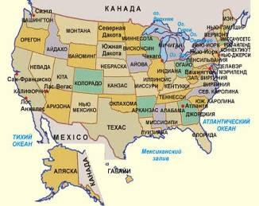

Приложение №2
New Plymouth

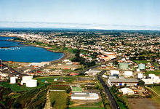
Приложение №3
bald eagle,
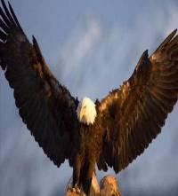
buffalo
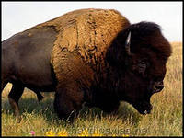
coyote
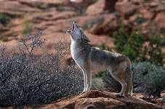
humming-bird
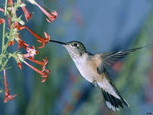
raccoon

rattle-snake
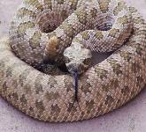
armadillo
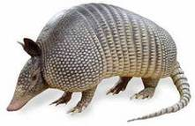

Jaguar
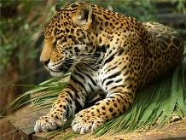
grizzly-bear
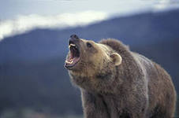
anteater
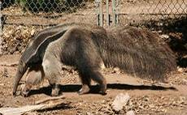
Приложение №4
Boston
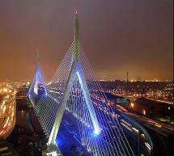
Приложение№5
Hollywood and Disneyland
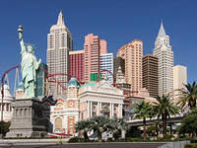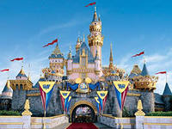

Приложение № 6
New York
Приложение №7
Washington

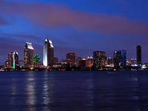
The Capitol Building,
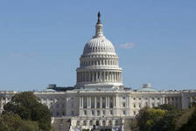
the White House

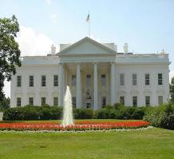
the Lincoln Memorial,
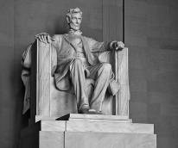

Приложение№8
New Orleans

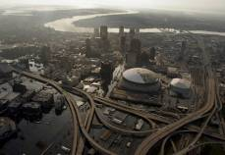

Приложение №9.
Презентацию выполнил студент 1 курса группы № 5 Васильев- Королёв Николай.

